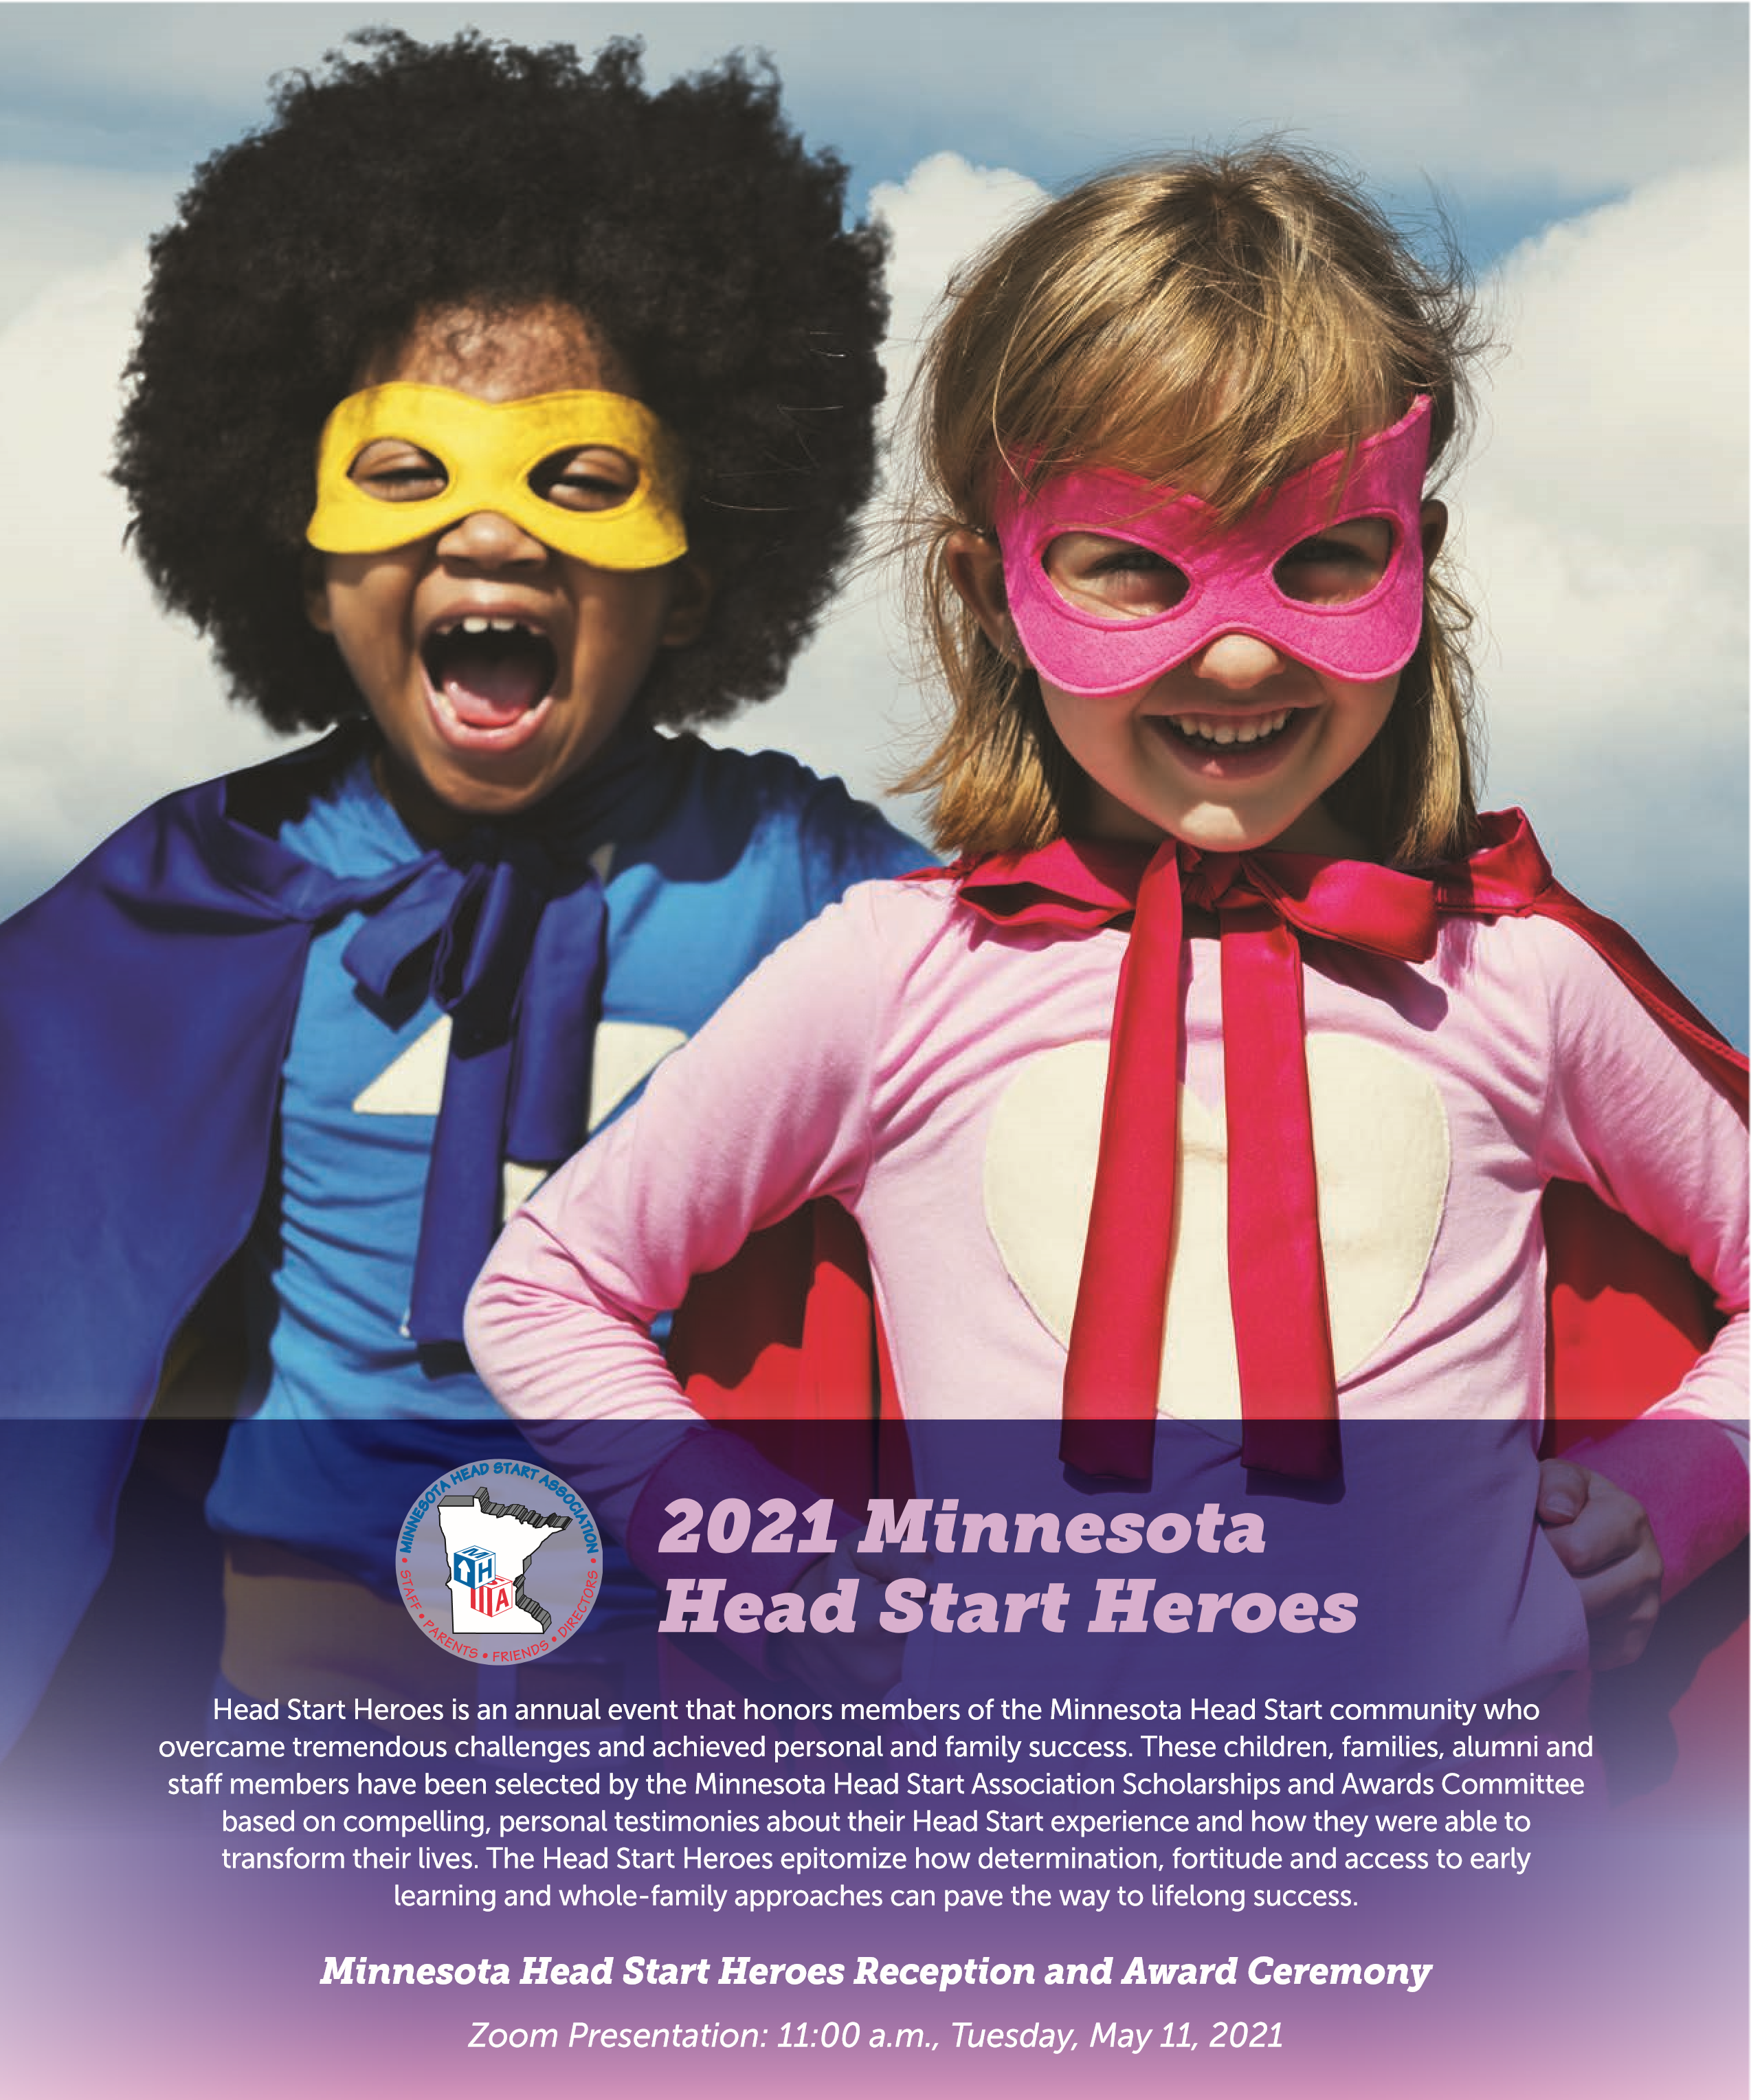
The Minnesota Head Start Association (MHSA) mission is to advocate for low-income families and inspire high standards of service for young children by providing innovative leadership and programs to help children, families, and communities reach their full potential.

Lety attended Sauk Center HS as a child for 2 years as a newly transplanted child from Mexico.
Lety worked as a Family Services worker for 2 years, 4 months. She works as an interpreter for the Community Services program and the weatherization program at TCC. Lety was recommended for her position by a TCC employee because of what she observed Lety doing at her job at Coborn’s, the local grocery store, based on her advocacy and assistance to the community.

C A T E G O R Y 1 : S T A F F M E M B E R
Head Start alumni who has become involved in their local program as a staff member and demonstrates a passion for serving through advocacy, career growth, or being involved in Head Start, the community, or the state/national level that benefits Head Start families.

Lety Ambriz Orozco
Tri-County Community Action Partnership
Lety’s passion for serving, developed Lety remembers her childhood, going through her life experiences. In to Kindergarten where she improved addition to interpreting for TCC, her English skills, many moves to she also assists at the area schools different houses, her siblings attending and police department. She teaches Early Head Start and Head Start. Quinceanera dances to the daughter Lety’s mother was instrumental in who are coming of age in the making sure she and her siblings community and creates events every got an education. But these good year. She assists in other community memories were shadowed by sad
projects as well. memories of abuse, substance use, and
continued incarceration, ending with
Lety’s story begins in her young another change of the family moving
childhood with a scorpion sting and Lety’s mom leaving her dad.
during her 1,000-mile trek across the Mexican desert to immigrate to As Lety became an adult, she applied the United States. As a three-year- for DACA, graduated from high old, this journey was long, often school, obtained a job at Coborn’s, being carried by the men in their and started her family. After three group when her legs grew weary. years of experience she applied After entering the U.S. their journey at TCC and joined their team. took them to Melrose, MN to stay Learning much about her own life with family while they searched in the process, she has grown much, for housing for the family of 3, and forgiven family for bad choices, another child on the way. and much more. “My desire is to be
someone to help and guide parents.
“As a child, I remember having
I would like to be instrumental in
the ride a little school bus to attend stopping the cycle of poverty.”
my Head Start class in a different town…I will never forget the day of my Head Start graduation. I stood in front of the cake and held my certificate high, as my mom took a picture of me. I was so happy. Later that same day, I spent the night at a jail lobby, as I waited for my dad to get out of jail.”

C A T E G O R Y 2 : F A M I L Y S U C C E S S
Head Start family who has made significant life changes within the past 12 months and is currently enrolled in a Head Start or Early Head Start program or is serving on a Policy Council.

Billi Jo Weaver
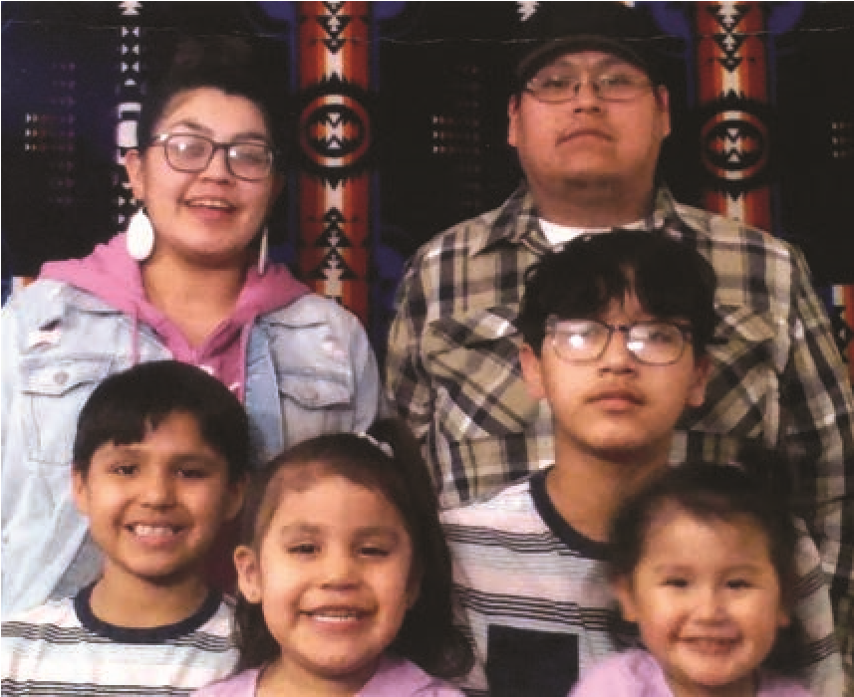
Mahube-Otwa Community Action

Billi has made huge strides this
year in all five of the areas that
build the foundation for Head Start;
health, employment, education and
is actively working on nutrition and
community support.
Billi grew up surrounded by addiction
and poverty. She did her very best to
avoid the trap of addiction and to get
her education, but just weeks shy of
graduation she dropped out of school.
She ended up in a cycle of poverty and
with her own addiction issues for a
number of years. During that time she
became a mother and as much as she
wanted to be the best mom possible,
the drugs were more powerful. She
ended up with her two boys in child
protection and a criminal record. When
Billi found out that she was expecting
her third child she knew that she had to
change her life.
Billi began to attend an outpatient
program, got clean and got her boys
back. When her daughter, Diane,
was born she signed up for the Early
Head Start Program. Diane was
soon followed by another daughter,
Cheyenne. By this time Billi Jo
had been able to get her girls into
the Early Head Start Family Child
Care program. This enabled her to
begin working to support herself
and her family. Her work was very
part time. She found it challenging
to keep a household running while
she worked. At one of our visits Billi
shared that she would love to get her
GED, so we took a couple hours and
went to visit Adult Basic Ed. When
I asked her what it would mean to
her to get her GED she replied, “Oh,
I would be so excited that I would
sign up for college right away.” She
was able to sign up and from that
point on, Billi began attending her
GED classes regularly and building
relationships with her instructors.
She is approaching this goal with
persistence and optimism.
One of her goals was to become a
legal driver. Due to some learning
disabilities, it has taken many tries
to pass her permit test. COVID
restrictions did not make the process
any easier. But with persistence and
the help of some mentors, she passed
her test in August and her road test in
September. She is a proud legal, fully
insured driver. Billi’s persistence
was her single biggest asset through
this process.
Billi is now working full time and no
longer depending on MFIP and food
support to keep her family going. She
is proudly looking forward to a future
where she will have college degree
and a home that she owns. She has
a smile that can light up a room and
does everything she needs to do with
joy. Billi is an amazing example of
resilience in the face of great odds.
2021 Minnesota Head Start Heroes

C A T E G O R Y 3 : C H I L D S U C C E S S
A currently enrolled child who has made tremendous developmental progress while enrolled in a Head Start / Early Head Start program.

Rakelle Guto
Parents In Community Action, Inc.
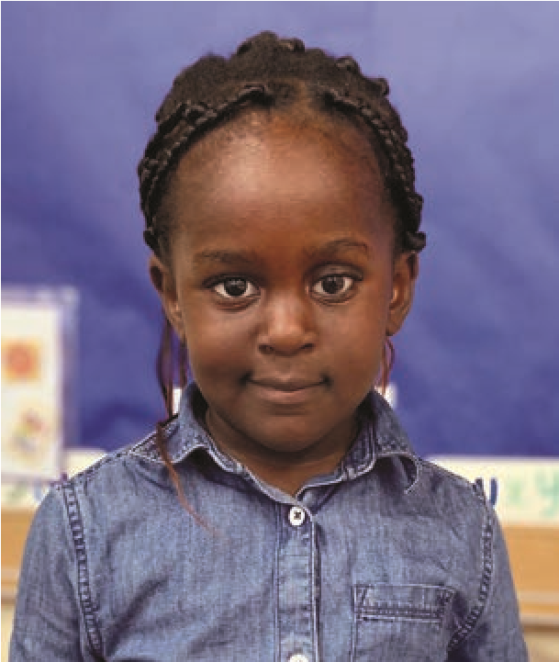
Rakelle is currently a 3-year old
attending PICA’s Southwood location
in Bloomington, MN. Rakelle was
initially enrolled as a toddler at PICA’s
Pond Center in 2018. When Rakelle
was enrolled and began attending,
she received a vision and hearing
screening at the center through the
screening team. There were concerns
that flagged from the screening and
it was later detected that Rakelle
had some optical issues in one eye.
Rakelle was later diagnosed with
cancer in that same eye and it was
determined that the eye needed to be
removed. Rakelle was out of school
for a short time undergoing treatment,
surgery and extended care needed.
Rakelle is now back to school and
attending regularly. She is thriving
with the functionality of her prosthetic
eye and is a happy little lady.
Rakelle comes to school each day
ready to start the day. She picks up
on everything very quickly. She can
write her first and last name and can
read fluently. She listens well for her
teachers and follows simple directions.
She has also developed good social
skills. Rakelle is very polite and cares
about other children and interacts well
with them.

C A T E G O R Y 4 : L O C A L A D V O C A T E
A Head Start alumni who has demonstrated advocacy by becoming involved in their local program or community, such as Policy Council, their agency’s Board of Directors, a parent committee / board at their public / private school, leadership in a local organization, etc.

Emily LeClaire
Tri-County Community Action Partnership
Emily is a single mother of
four children, all of whom have
participated in Head Start or Early
Head Start. She came to Head Start
in Crow Wing county through New
Pathways, a homeless shelter /
program. After separating from her
husband, she was no longer able to
afford rent on her income. This was
a humbling time in her life, and it
gave her the opportunity to serve
other homeless families at the shelter.
Being one of few with a vehicle, she
gave rides to other families, as well
as babysitting while they worked.
Enrolling all her children in Head Start
and Early Head Start, she also enrolled
in the prenatal program. Receiving
visits at the shelter was helpful and
appreciated, as it brought normalcy
to this difficult and vulnerable time.
Activities with the kids kept them
all occupied and learning, spending
quality time together. “Reassurance
and acknowledgement from the staff
meant a lot and made me feel valued.”
Leaving the program for a short
time due to work schedules, they
re-enrolled. She became involved
in their parent committee and was
elected as the committee secretary.
At the same time, she was elected to
Policy Council, also serving there as
secretary. She is now the chair of the
parent committee, serves on Policy
Council, is a parent representative
to MHSA, and was elected to the
MHSA Board of Directors.
“The more involved I got in HS
program governance, the more
passionate I have become about it…
visiting the State Capitol last year
with MHSA was a real eye-opening
experience for me. This opportunity
helped me realize that I wanted to
advocate for Head Start, children,
and those experiencing poverty on
a higher level.” She has since run
for a seat on the local district school
board. She may not have won the
seat, but the 3,000+ votes surprised
and encouraged her as she didn’t
have much time as a single parent
to campaign.
Through the parent committee and
Policy Council, she has learned to
listen to the opinions of those around
me, share information concisely and
compromise at times to ensure the
best results for all of the children and
families we work to serve.

2021 Minnesota Head Start Heroes

C A T E G O R Y 5 : P A R E N T S C H O L A R S H I P
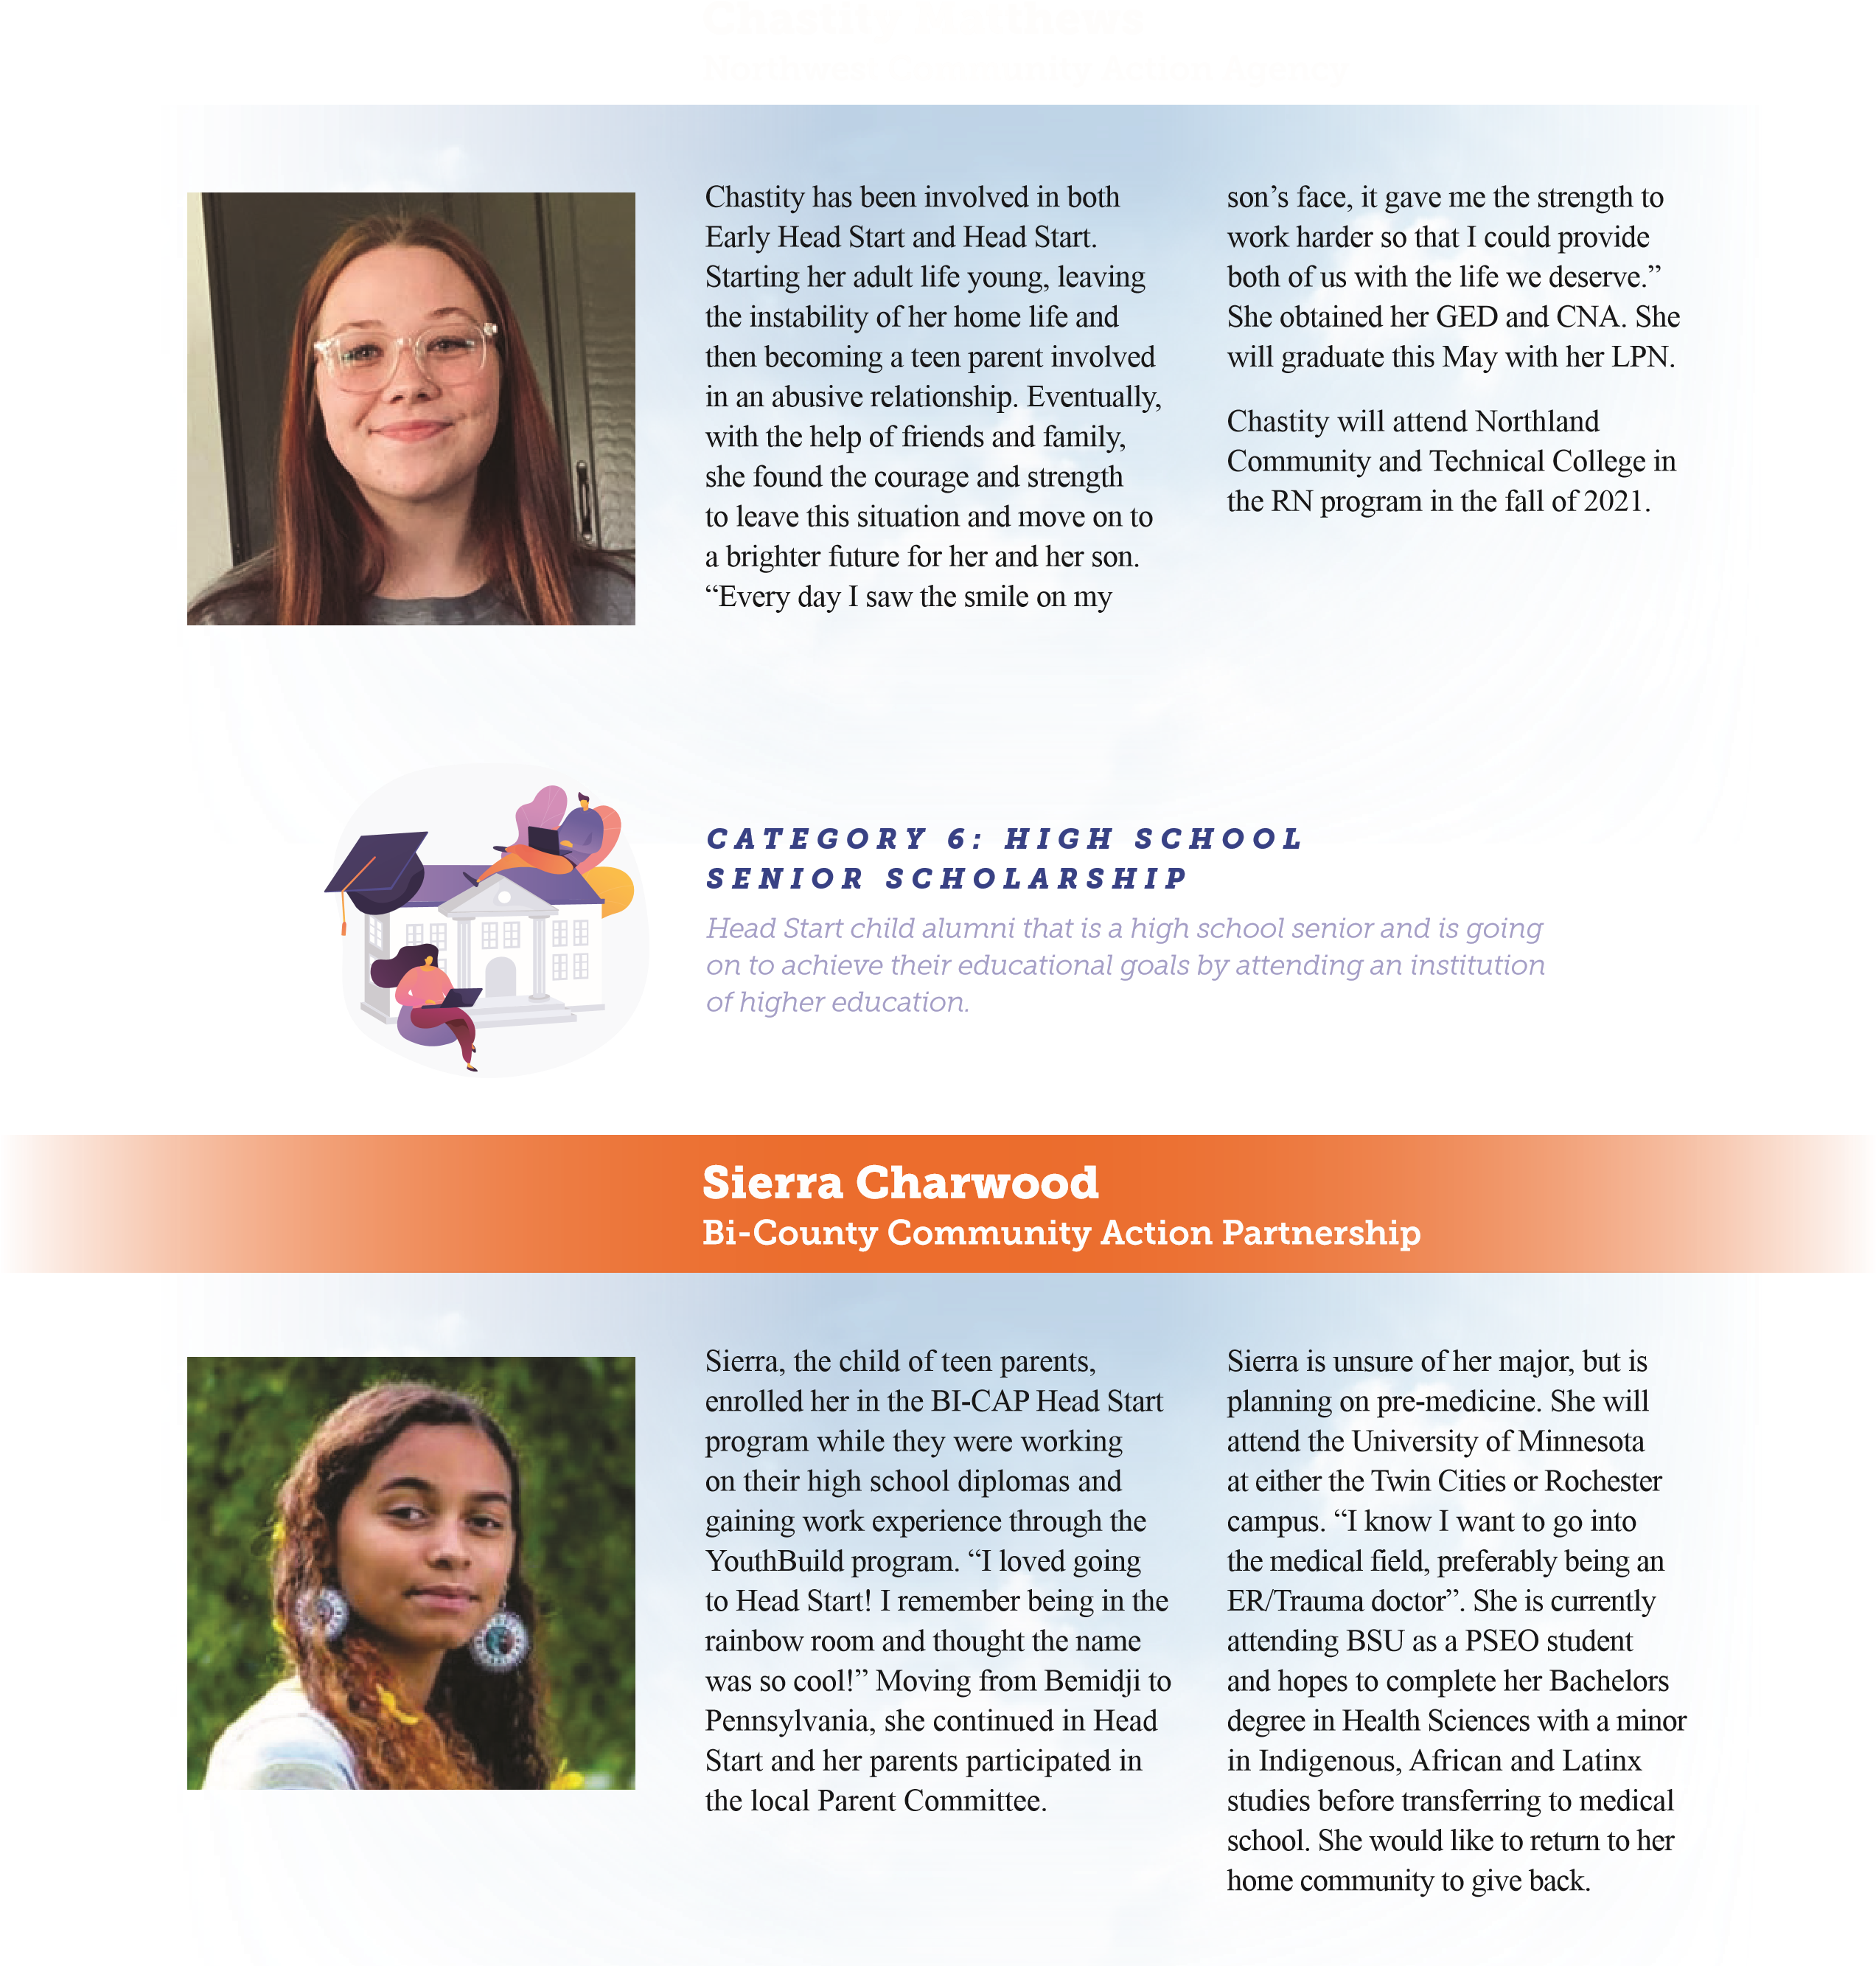
Head Start child alumni or current/past parent that is going on to achieve their education goals by attending an institution of higher education.
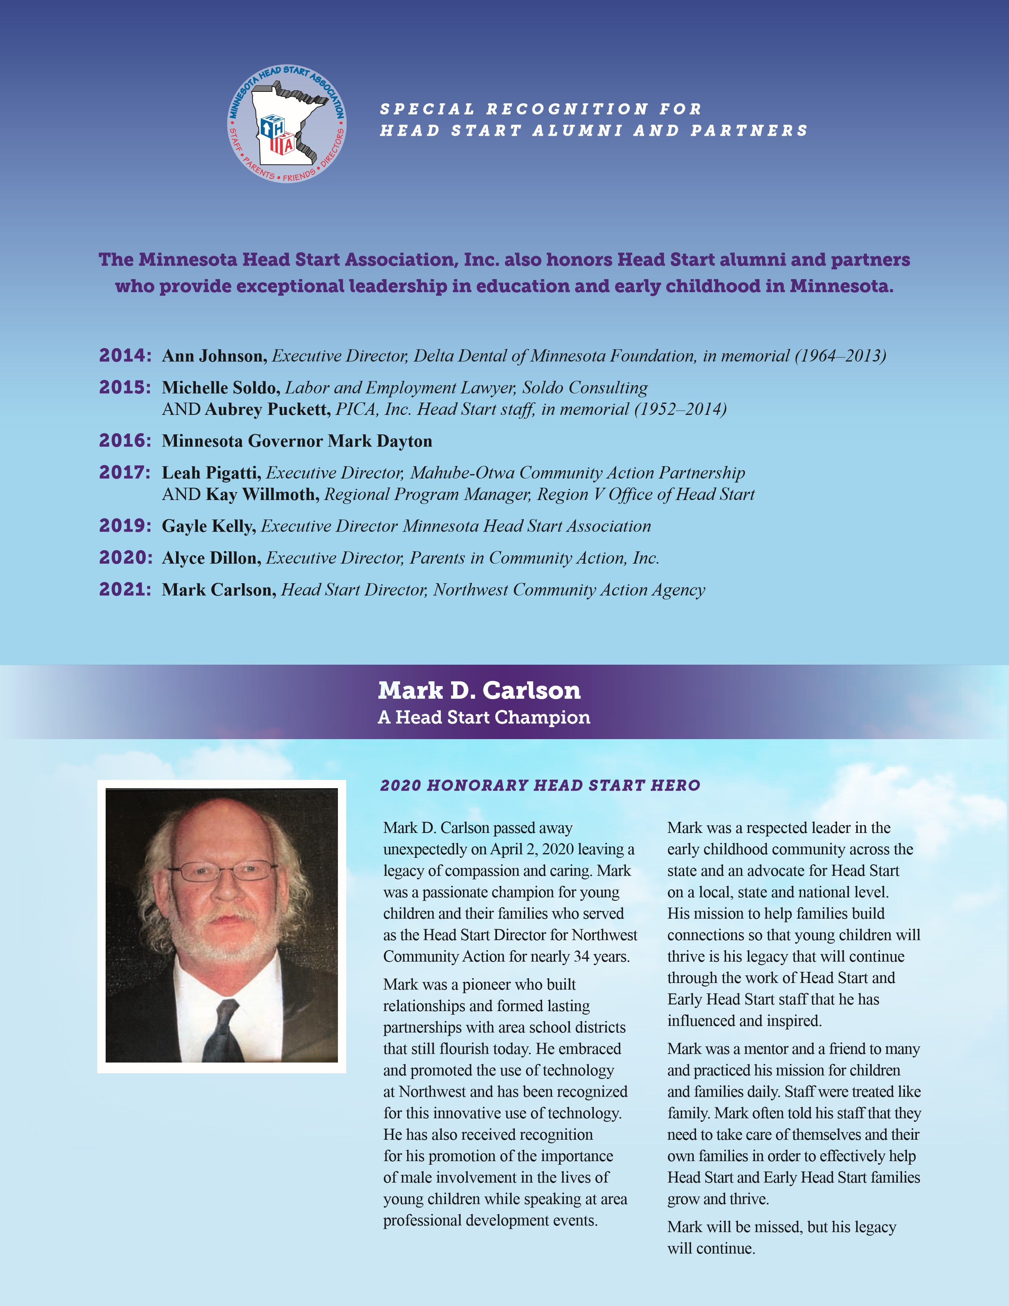

and families in need.
- Many centers staying open for the children of front line workers
- At a moments notice gearing up for virtual services – staying connected to families from their own homes, often their own kitchen tables, creating a new picture of family engagement on a more personal level
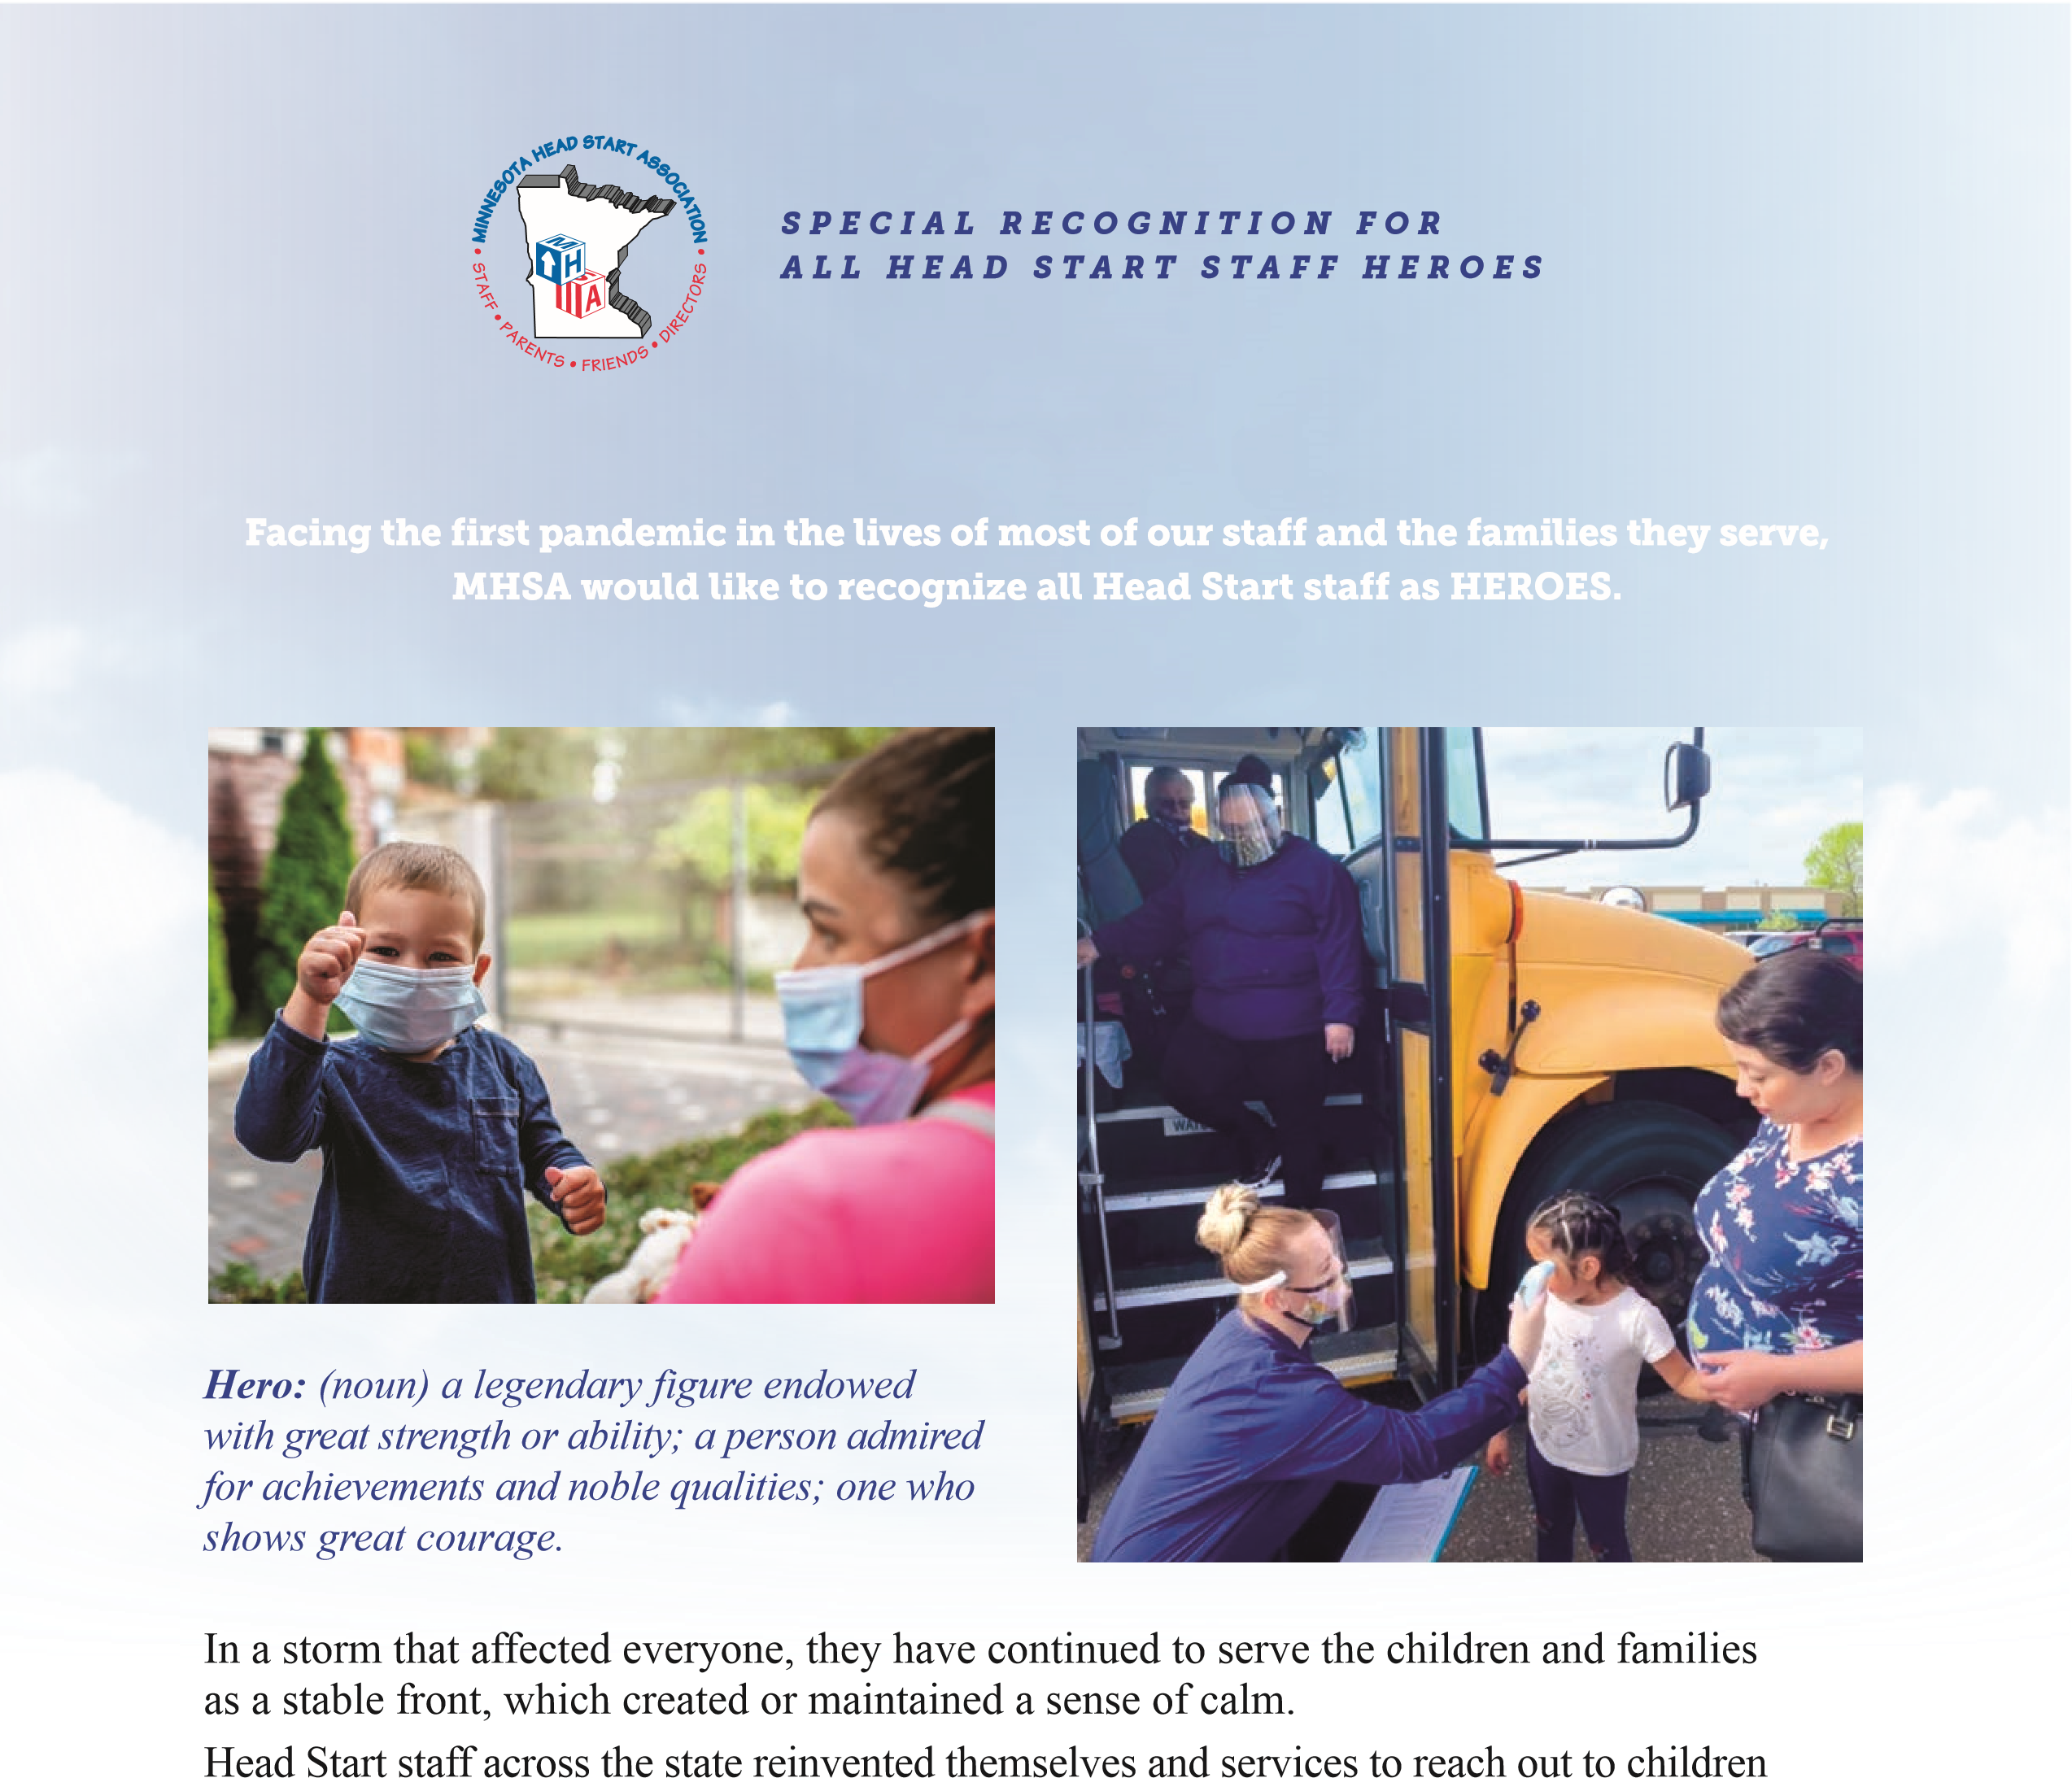
- Some home visitors and family advocates continued to provide in home services to those families in crisis
- Providing virtual circle time and socializations
- Delivering food and supplies directly to families’ homes
- Providing an up to date list for all families of resources available in the community – especially new resources provided for COVID-19 response
MHSA would like to thank all Head Start staff for all that you do for children and families, not only during this pandemic, but always.

