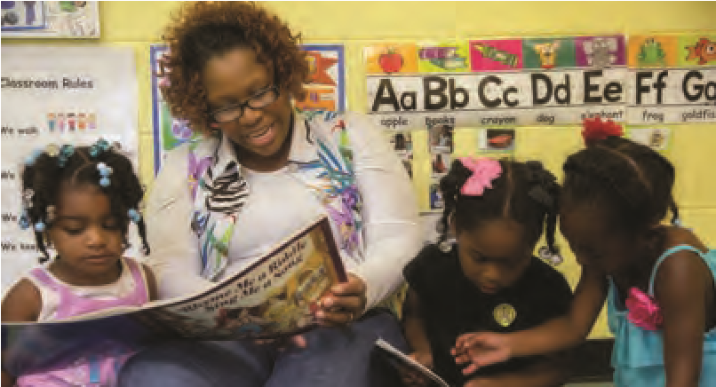
Minnesota Head Start
Facts 2019
When Parents were
asked:
Why did you
choose Head Start for
your family?
•
Head Start offered more social
interaction opportunities, longer
hours and family involvement.
•
H ead Start cared about the success

of my family, not just my child.
•
H ead Start offered us good resources

that helped us financially and helped
both me and my child emotionally.
Children in Poverty and Access to Head Start
In 2017 – 2018, there were
69,310
children in poverty under age five in Minnesota.
Of those, only
46
%
of three and four year olds had access to Head Start. And only
%
9
of children under 3 had access to Early Head Start.
Children and Families Served:
By the Numbers

10,803
Head Start
Enrollment
3,098
Early Head Start
Enrollment
%
55
Racially Diverse

%
15
with a Disability
418
EHS/Child Care
Partnership Enrollment
32
%
English Not
Primary Language
14
%
Homeless or
in Foster Care
Head Start in Local Communities
Minnesota’s 33 Head Start and Early Head Start programs fuel the local economies of the communities in their service areas. In 2017 – 2018 these Minnesota investments included:
3,438
Employees with Benefits

8,417
Children Transported

6,137
Children Receiving Services in Full Day Options

Est. $30
Million in Local Purchases of Food,
Gas, Diapers and Other Purchases

15,700
Volunteers

71%  had access to family  services including crisis  intervention, job training and parenting education | 97%  were up-to-date on immunizations | 99%  had access to a medical home | 88%  had access to a  dental home

Comprehensive Health and Family Support
Head Start takes a comprehensive approach to meeting the needs of the whole child and family. This two generation approach supports stability and long-term success for families experiencing economic hardships. Thanks to Head Start’s comprehensive services, by the end of the year children and families received these health and family outcomes:
Source: State and Federal Enrollment, Minnesota Department of Education and 2017 – 2018 Federal Program Information Report, Minnesota.
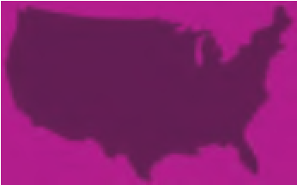
Minnesota Head Start

Child Outcomes Data
What Impacts Children’s Gains?
Child and classroom characteristics that were associated with larger gains Fall to Spring for 4 year olds include:
- C hildren who miss less than 10% of school days
- Children with Early Head Start experience or Head Start as
year olds
- Classrooms with lower teacher turnover
- Classrooms with a lower percentage of 3 year olds
- Teachers with higher combined
CLASS scores (Classroom Assessment Scoring System measures teacher/child interactions)
With Minnesota’s expansion of State Preschool, Head Start experienced major turnover in teachers and increases in the number of 3 year olds in Head Start classrooms. Head Start programs are training new staff and adjusting child ratios to accommodate for these changes. Educating parents about the lasting benefits of regular attendance in preschool has been a priority for programs statewide.

Achievement Gains for All Children
■
Not At-Risk
■
At-Risk
360
340
320
300
280
260
240
220
200
180
TS Gold: Avg Summated Rating for all Domains
Fall
Winter
Spring
Children entering Head Start as 4 year olds vary considerably in their early experiences. There is a wide gap in children’s Fall assessment scores based on their experiences and individual risk factors. Head Start programs identify children at-risk of not meeting school readiness benchmarks using Fall assessments. In 2017/18, children identified at-risk in the Fall made better than average achievement gains (87 versus 75 point gains) across all domains of learning during the year.
ACHIEVEMENT GAINS FOR 4 YEAR OLD:
RISK GROUPS IDENTIFIED IN FALL

Experience Matters: Early Intervention Pays Off
Children in families who participate in Early Head Start get an extra boost. Head Start children have better than age-expect outcomes when they attend Early Head Start or Head Start for multiple years. Rich experiences provided through these programs support developmental gains across all domains of learning that persist from year to year. In 2017/18, 56% of Head Start children had only one year of service.
FALL ASSESSMENT SCORES FOR 4 YEAR OLDS:
Age
OR 2+ YEARS EHS/HS
1
300
290
280
270
260
250
240
230
220
4.9–5
4
–4.1
4.1–4.2 4.2–4.3 4.3–4.4 4.4–4.5 4.5–4.6 4.6–4.7 4.7–4.8 4.8–4.9

■
2+ Yrs HS
■
First Yr HS
TS Gold: Avg Summated Rating for all Domains
When Parents were asked: Why did you choose Head Start for your child?
- We liked the small class sizes (and adult/child ratio) – larger kindergarten class was overwhelming for my granddaughter last year.
- Head Start was highly recommended by Public Health and my child’s therapist.
- We had no children of the same age in our neighborhood so I wanted a place where my child could interact with peers for some hours each day.
- We liked the home visit component because it is important for teachers to see my child’s home environment.
- We noticed that children who went to Head Start did well in school and life.
Head Start and Early Head Start Workforce by The Numbers
CDA – Center-based  Preschool | 115
CDA – Center-based  Infant/Toddler | 72
CDA – Home Visitor | 36
Family Service  Credential | 108
AA | 42
BA/BS | 34
MA | 2
Total | 409
Total # of Staff who are Former
HS Parents
1,031 (30%)
Total # of Staff 3,438
Total # of Teachers
(Birth to 5)
998
Total # of Racially  Diverse Teachers  299 (30%) |  | Total # of  Bilingual Teachers  355 (35%)
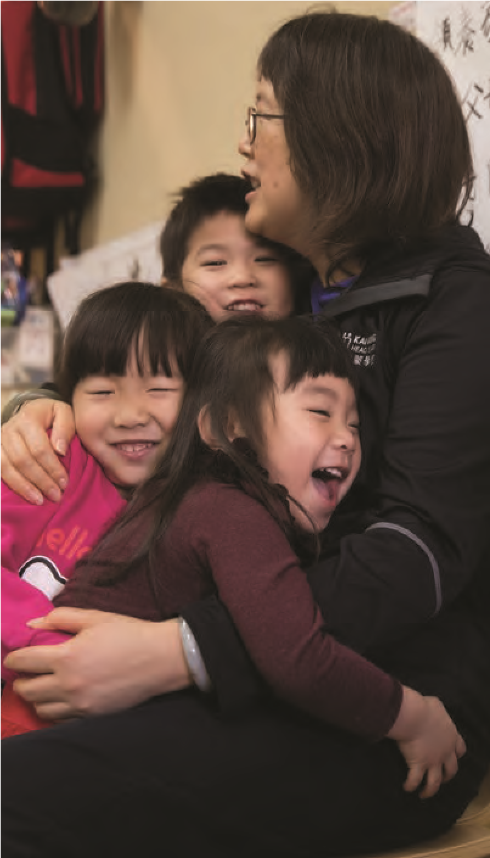
CREDIT-BASED
Minnesota Head Start

Growing the Head Start Workforce
Shortage of
Qualified Teachers
A qualified, well-trained and culturally diverse
early childhood workforce is essential for
Head Start to serve Minnesota families.
Head Start programs cultivate staff with
traditional early childhood degree programs
both BA and AA) as well as recruit interested
(
parents who reflect the backgrounds of
the children it serves. There is currently a
shortage of degree-qualified early childhood
professionals in the field in large part due to
expansion of State Preschool and historically
low wages for early childhood jobs. Over
the past 4 years, Head Start has seen
about a 5% shift from BA to AA teachers.
Supporting Professional Development
at the Workplace
Regardless of entry qualifications, all teachers receive training and professional development
to meet Head Start standards and work with parents and children. In addition, Head Start
programs support staff (partially or fully) to receive early childhood credentials and credit-
based learning. During the 2017/2018 school year, a total of 409 child development staff
(
or 40% of teachers) accessed professional development to advance their careers.
CREDENTIAL OR
■

TEACHERS BA/MA

■

TEACHERS AA
2014
2018
67
%
30
%
62
%
%
35
SUPPORT # OF TEACHERS
Source: 2017 – 2018 Federal Program Information Report, Minnesota
Minnesota Head Start Minnesota Head Start Programs 2017

Programs 2019
Head Start Agency Headquarters Phone No.

Anoka County Community Action Program, Inc. Blaine 763-783-4300
Arrowhead Economic Opportunity Agency, Inc. Virginia 218-748-7335
Bi-County Community Action Program, Inc. Bemidji 218-751-4631
Bois Forte Reservation Tribal Council Nett Lake 218-754-3265
Child Care Resource and Referral, Inc. Rochester 507-287-2020
Community Action Partnership of Ramsey & Washington Counties St. Paul 651-645-6445
Duluth Head Start Duluth 218-336-8815
Fond du Lac Reservation Business Committee Cloquet 218-878-8100
Grand Portage Reservation Tribal Council Grand Portage 218-475-2234
Inter-County Community Council, Inc. Oklee 218-796-5144
Kootasca Community Action, Inc. Grand Rapids 218-999-0814
Lakes and Pines Community Action Council, Inc. Mora 320-679-1800
Lakes & Prairies Community Action Partnership Moorhead 218-512-1500
Leech Lake Reservation Tribal Council Cass Lake 218-335-8345
Lower Sioux Cansayapi Early Head Start Morton 507-697-6195
Mahube-Otwa Community Action Partnership Detroit Lakes 218-847-1385
Mille Lacs Band of Ojibwe Indians Onamia 320-532-7590
Minnesota Valley Action Council, Inc. Mankato 507-345-6822
Northwest Community Action, Inc. Badger 218-528-3227
Parents in Community Action, Inc. Minneapolis 612-374-8309
Prairie Five Community Action Council, Inc. Madison 320-598-3118
Reach-Up, Inc. St. Cloud 320-253-8110
Red Lake Tribal Government Red Lake 218-679-3396
Scott-Carver-Dakota CAP Agency, Inc. Shakopee 651-322-3500
Semcac Rushford 507-864-7741
Southwestern Minnesota Opportunity Council, Inc. Worthington 507-376-4195
Three Rivers Community Action, Inc. Zumbrota 507-732-7391
Tri-County Community Action Partnership, Inc. Little Falls 320-632-3691
Tri-Valley Opportunity Council, Inc. Crookston 218-281-5832
United Community Action Partnership Willmar 320-235-0850
West Central Minnesota Communities Action, Inc. Elbow Lake 218-685-4486
White Earth Reservation Tribal Council White Earth 218-983-3285
Wright County Community Action, Inc. Maple Lake 320-963-6500

For a listing of Head Start programs by county go to: http://www.mnheadstart.org/grantees.html

For more information contact: Minnesota Head Start Association, Inc.
www.mnheadstart.org
Gayle Kelly, Executive Director (218) 728-1091 or Fax (218) 728-0083 gayle@mnheadstart.org

